Practical no. 01
Aim:- Write a Program In Order To Explain The Concepts Of Class And Objects.
  - Create simple car class and create its object.
INPUT:-

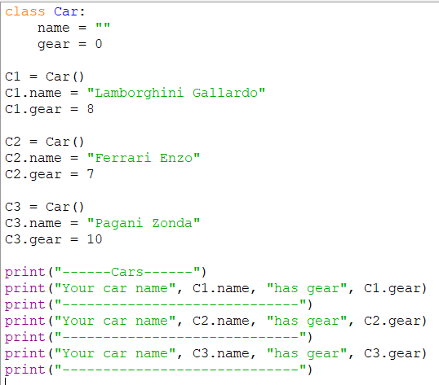
OUTPUT:-

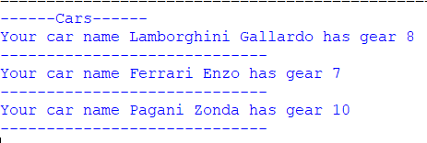

  - Making A Class For Circle.
INPUT:-
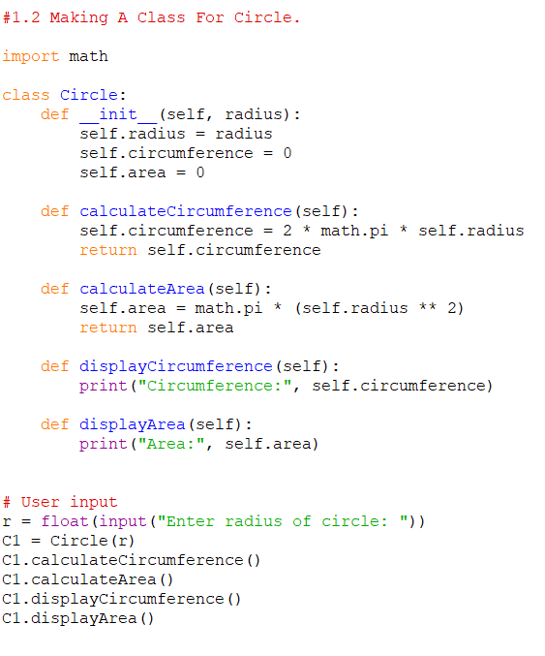
OUTPUT:-

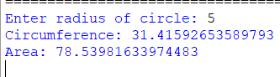

  - Example of constructor :-

INPUT:-

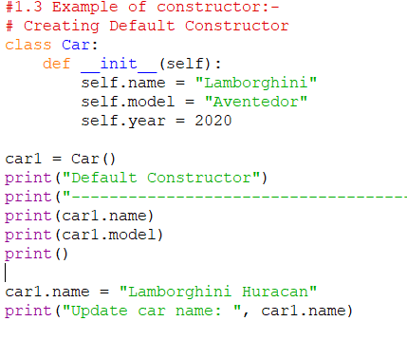

OUTPUT:-

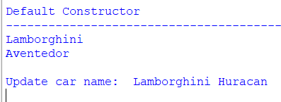

  - Destructor :- deletes the objects

INPUT:-

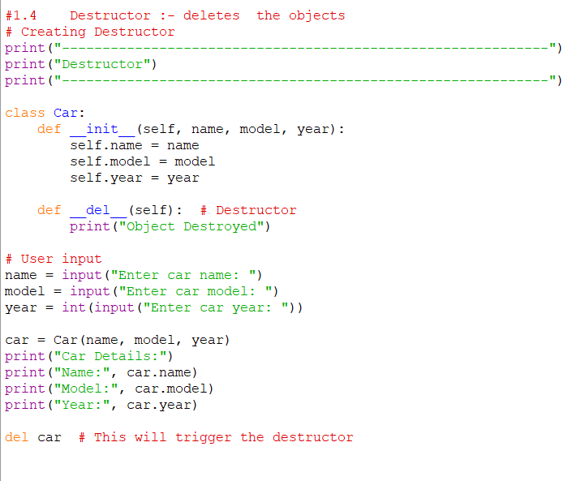

OUTPUT:-

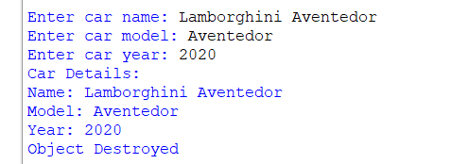

  - Employee Biodata collection:-
INPUT:-
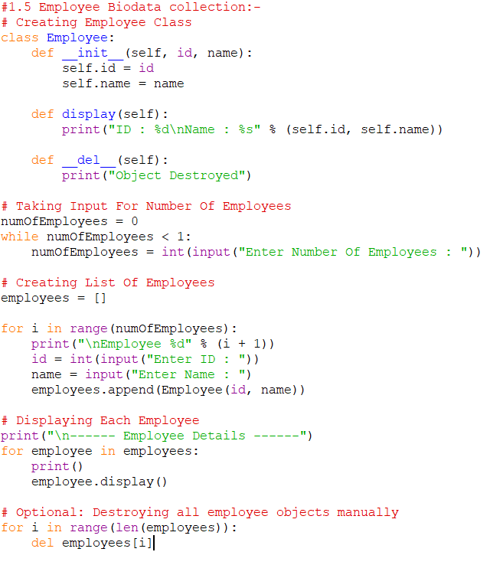
OUTPUT:-
